TITLE: Generating Food Suggestions Based on user input

ABSTRACT:

Getting through monthly menstruation is a thing in itself. Food should be the least of any woman’s worries during this time. All women go through this never-ending process of not knowing what to eat but just wanting to eat something, AKA cravings. We wish to make a website or an app that acts as a simulator to help women all over the world get better food suggestions for the kind of cravings and common symptoms, like bloating, cramps, irritability, headaches, etc., they have during their monthly menstrual cycle. We plan on doing so with the help of filters, which allows the users to select from various options provided in the filters, and CookBook, a recipe guide, to get food suggestions for their cravings and symptoms. This app or website aims to help women eat what they crave while maintaining their health. So, the recommendations would also include the calorie count of each item in the recipe or the overall recipe so that all women worldwide need not stress over over-eating and live peacefully, staying healthy.

INTRODUCTION:

Food cravings during menstruation are other things that all women worldwide share in common. Along with these cravings, there are symptoms like bloating, cramps, irritability, headaches, etc., which makes their life even more difficult. These symptoms often affect one’s mood. What if they can get relief from these kinds of signs and calm down the cravings with the help of food? Well, we have just the right solution for this problem. Our website, *Cravings Hub,* is designed in such a way that it could give food suggestions to women based on their cravings and the common symptoms that occur during menstruation, with the help of Filters and CookBook. The FILTERS have options like - Meal of the day: Breakfast, Lunch, Dinner, and Beverages; Meal type: Vegetarian, Non-Vegetarian, Gluten-free, Vegan; Symptoms: Bloating, Fatigue, Cramps, Heaviness in head / Headache, and Irritability. The COOKBOOK is designed so that the user can give either ingredients or the main dish leading to a search bar, which would provide many suggestions for the user to choose from to calm down their cravings. There are a few additions to come on the HOME page, like some useful links that would direct the users to another page that has helpful content like *what to do when: having heavy cramps, unbearable headaches, etc.; foods to avoid; Situation-Suitable product recommendations* and some content similar to what’s mentioned.

CONTRIBUTION:

Methods:

The languages HTML and CSS are used to design the front end of the website. The nav bar consists of Home, About, Filters, CookBook, and a Contact form. Among these sections: - on the home page, there is the company logo, which was created using Figma, the company name, tagline, and a dummy representation of the recipes list and recipe cards which are later to be changed to the ‘useful content’ section. On the About page, there is a short description of the aim of the website, and the team members’ information. The copyrights are on the footer of the webpage, where the date/year is updated in real-time. The Filters page has a set of options, for the user to choose from, such as Meal of the day: Breakfast, Lunch, Dinner, and Beverages; Meal type: Vegetarian, Non-Vegetarian, Gluten-free, Vegan; Symptoms: Bloating, Fatigue, Cramps, Heaviness in head / Headache, and Irritability, upon the selection, the user would be returned with some food suggestions that match with their request along with calorie count, link to the recipe, and the total time required to make that dish. A database, created on Microsoft access, with all these options and related recipes is linked to the website using a python script. The CookBook page has a search bar, where the user can enter either an ingredient name or the primary dish name, with the help of which, some recipes would be directly suggested, without any need to use filters, containing either the ingredient or the primary dish name along with the [……]. Edamam.com’s Recipe Search API is being used to show the results on the CookBook page. The Contact Page has a form for the user to fill out if they feel the need to get in touch with the creators. At the bottom of this Contact form, a few popular recipes are displayed. The design of company logo and name on the HOME page, ABOUT page, and CookBook page are designed and linked appropriately to get the results by our team member-1: Shirin Sultana Shaik. On the FILTERS page, the scripting that was required to connect the database to the website, and on the HOME page, the ‘useful content’ section that is to be added yet is being designed by team member-2: Shaik Juveria. The database required for the FILTERS page and the CONTACT form is created by team member-3: Punati Venkata Swetha.

Methods & materials

DISCUSSION:

**Home Page**

**About Page**

**Filters Page**

**CookBook Page**

ANALYSIS:

User can search required recipe from cookbook. Here are the search results of cookbook page.

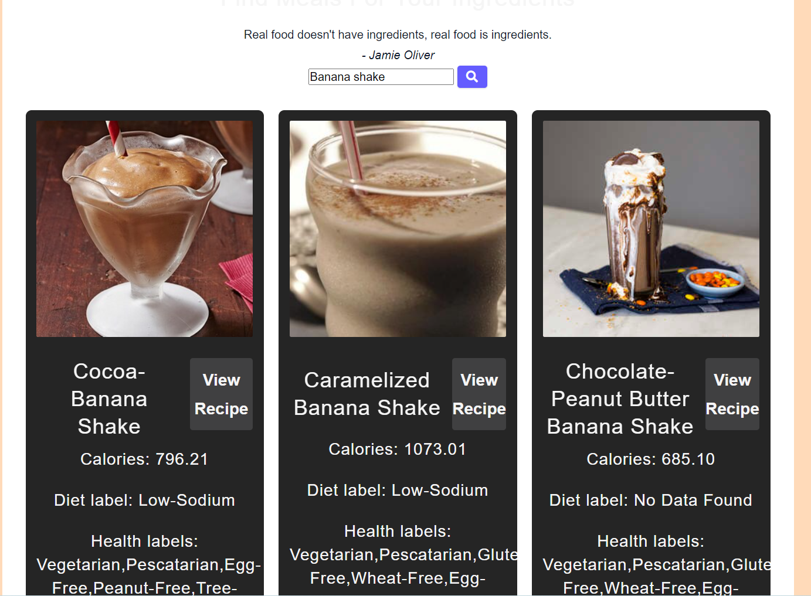

CONCLUSIONS:

We created a web page that helps women which helps to deal with different issues during menstrual cycle. Our page is interactive to users.

FUTURE WORK:

In the future, if there is provided scope for this website to grow by hypothetical users, this website can be useful not only for women going through the menstruation cycle but also for pregnant women, as the cravings and the common symptoms that we take about in the previous sections are usual in pregnancy too but these symptoms may vary from what they could be during menstruation. If such an audience were to make use of this website, they must be mindful of the food suggestions, as some recipes might contain ingredients that might not benefit the said audience.

Additionally, an application could be developed that could contain suitable medications for the appropriate issue, a custom-generated diet, and yoga/exercise information that might help the target audience stay healthy.

REFERENCES:

[1] https://adrianmeule.files.wordpress.com/2017/03/richard_2017_appetite.pdf

[2] https://web.archive.org/web/20200909004544/https://academicjournals.org/journal/IJNAM/article-full-text-pdf/F0B4E8964399.pdf

[3] https://www.hsph.harvard.edu/nutritionsource/cravings/

[4] https://www.ncbi.nlm.nih.gov/pmc/articles/PMC4172095/